HTML/HTML5

14 October 2024

04:09 AM

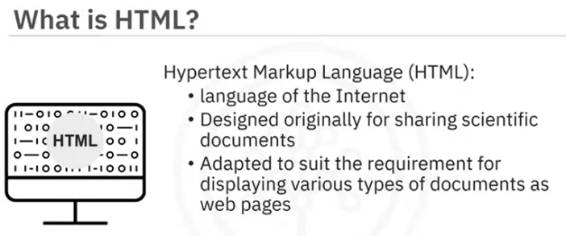

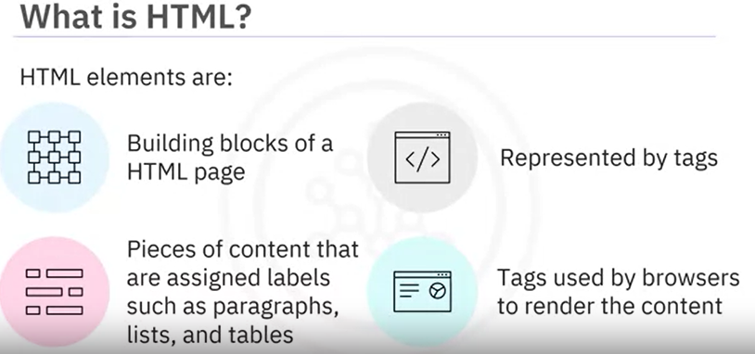

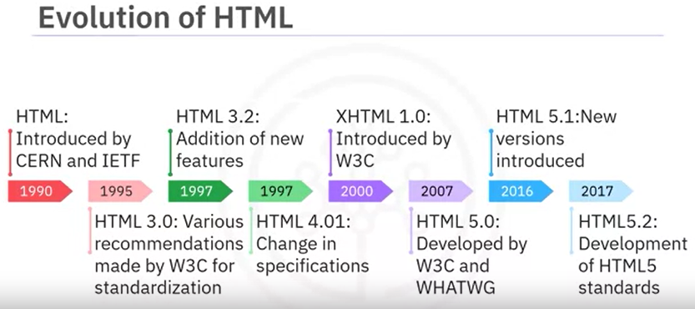

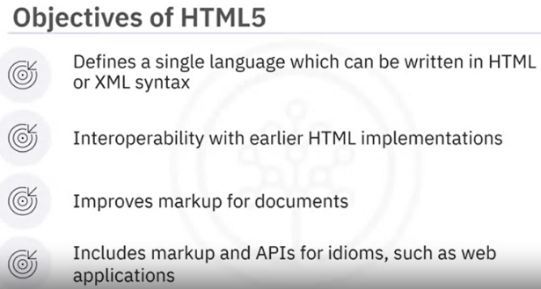

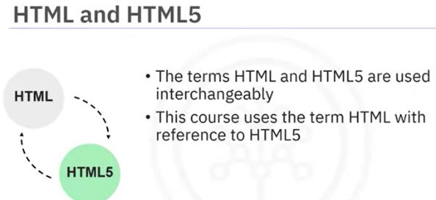

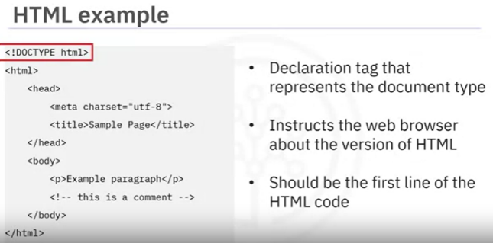

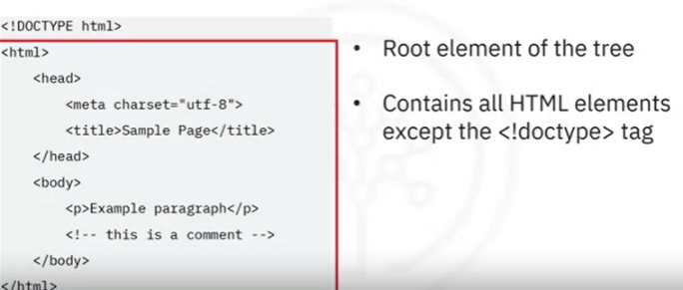

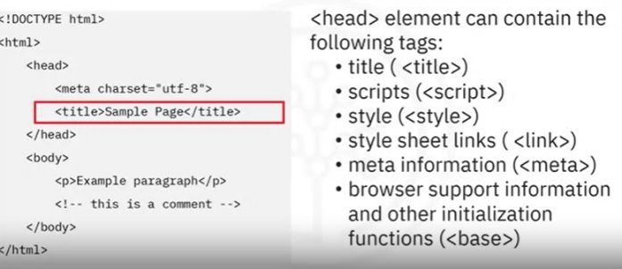

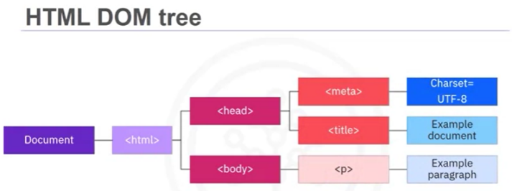

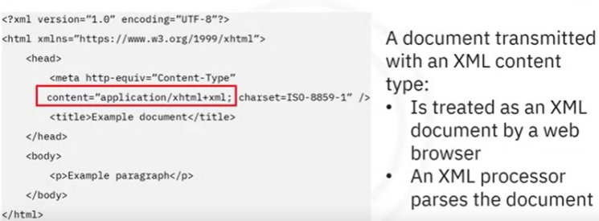

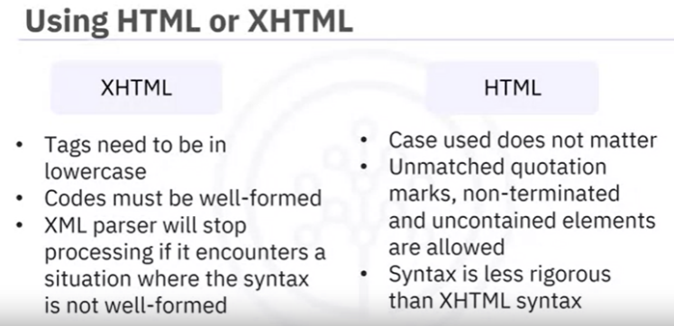

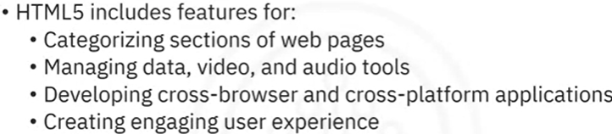

**What is JSFiddle?**

JSFiddle is a playground for novice and experienced web developers alike. It is an online web application which allows anyone to play around with HTML, CSS, and JavaScript. As you make changes, you can see the impact of those changes live.

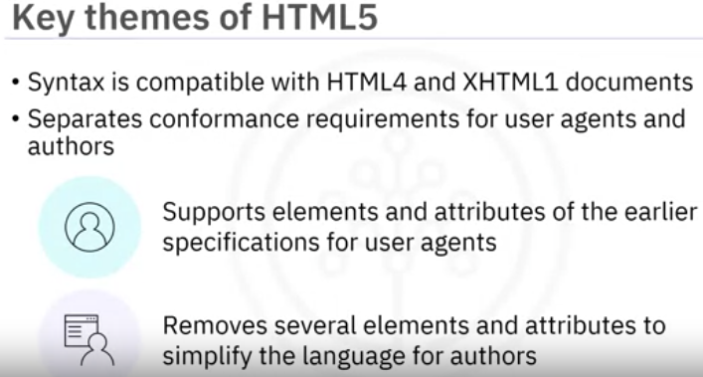

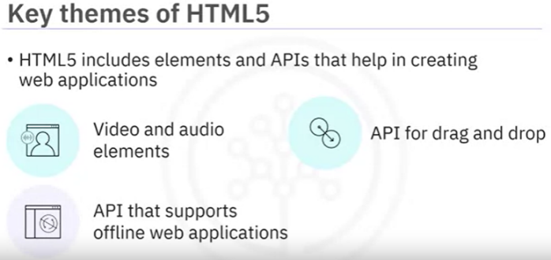

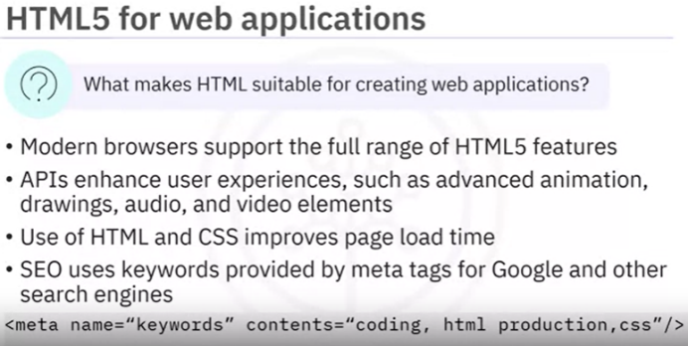

*Efficient use of HTML improves age load time

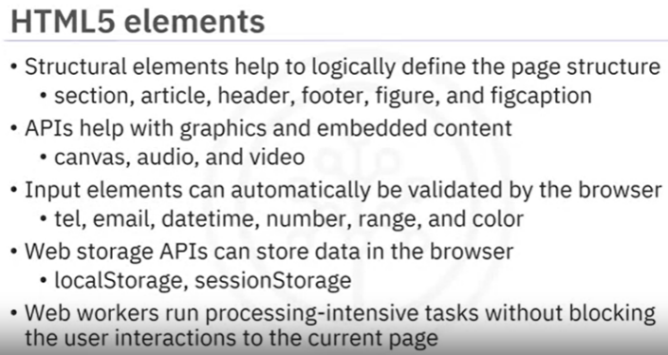

The <head> tag defines the metadata about the page, which is used by browsers and search engines.

This information may include the document title, character set, styles to be used, scripts, etc.

Contents of <head> section are not displayed to the user.

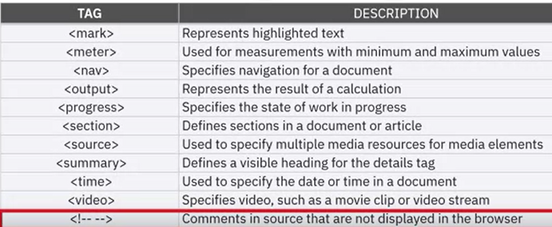

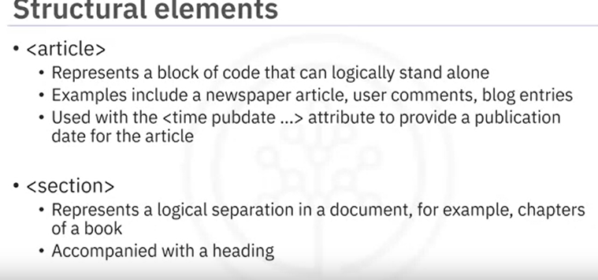

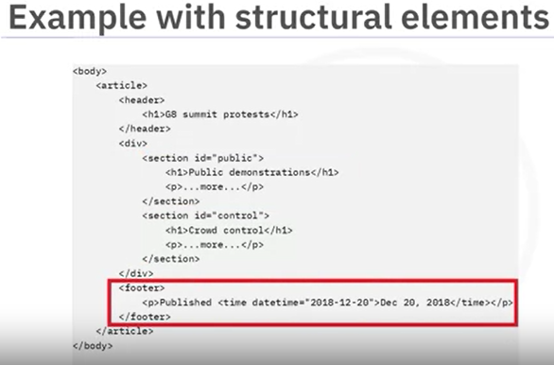

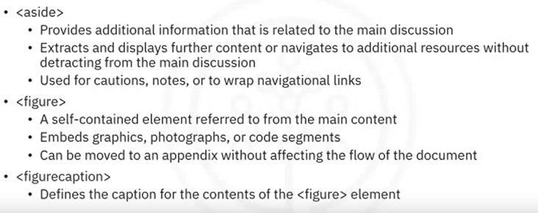

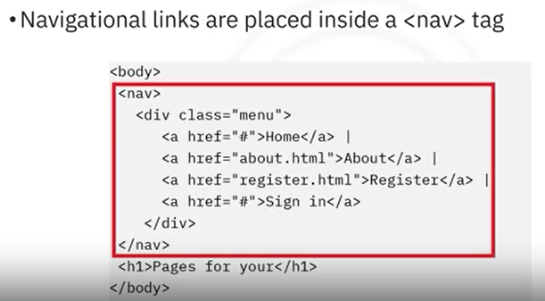

**Div tag:**

* + <div> tags are commonly used when many elements are required to have the same format.
  + Grouping such elements together in the same <div> tag enables a developer to easily style them by either using a class or an id.
  + When using a <div> tag, note that browsers will insert a line break before and after the element.

**Section tag:**

* + content in a more specific way than the <div> tag, Content within a <section> tag has a theme, which is usually indicated by a heading tag (e.g. <h1>) used immediately after the opening <section> tag.

* + 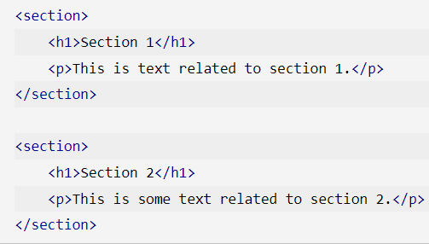

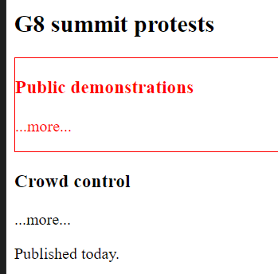

**Article tag:**

* + used to group together semantically related, self-contained content which can be meaningful on its own. Similar to the <section> element, articles usually have headings immediately after their opening tag to indicate what the article is about.

* + 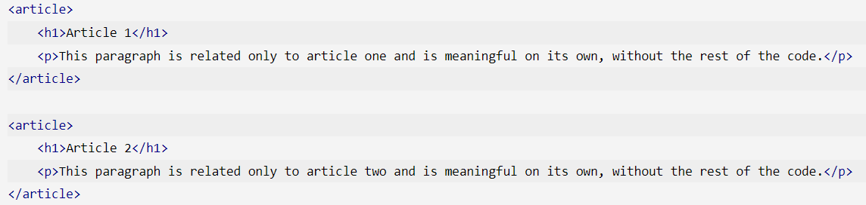

**Aside tag:**

* + used to provide additional information related to the main discussion​.
  + It lets you display further content or additional resources without detracting from the main discussion​, and is often placed as a sidebar in a document.
  + While the <aside> element itself is not displayed different from the rest of the content, it is useful for understanding your code and for styling purposes.

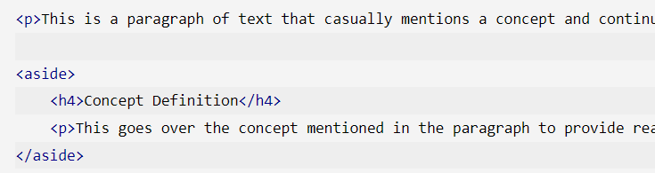

Figure and figcaption tag:

* + self-contained content, such as a diagram or photo, that is referred to from the main content​. The content within the <figure> element should be related to the main content, but still independent in such a way that if removed from the document, it would not affect the flow.
  + The <figcaption> tag defines the caption for the contents of the <figure> element​. It can be placed as the first or last child element within the <figure> element​.

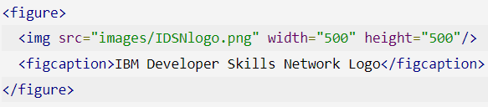

**Nav tag:**

* + The <nav> tag is a convenience tag which does not alter the appearance on webpages. However, it is useful in styling all navigational elements, as well as omitting the content for certain functionalities, such as with screen readers.

**Audio tag:**

* + used to embed sound content, such as music or podcasts. It contains one or more <source> tags with different audio sources (e.g. MP3, WAV), so the browser can select the first supported source to play.
  + If a browser does not support the audio formats provided, the browser will instead display any text within the <audio> element.
  + 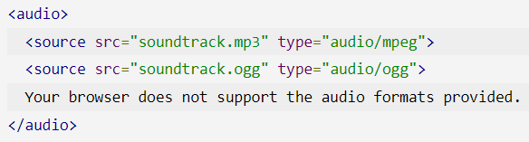

**Embed tag:**

* + used as a container to embed external resources such as media players and plug-in applications into your web page.
  + <embed type="text/html" src="another_webpage.html">

**Track tag:**

* + The <track> element defines text tracks, such as subtitles or captions, for <audio> and <video> elements.
  + This text should be visible as the related media source it playing, and are formatted in the WebVTT (.vtt) format.
  + 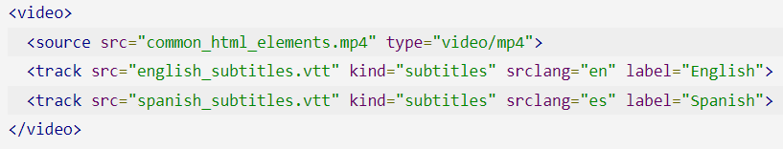
  + The HTML <fieldset> tag is found within the <form> tag and is used to group related elements in an HTML form, often by enclosing them within a box.

**disabled**: It specifies that the elements belonging to the fieldset should be disabled.

**form**: It specifies the id of the form that the fieldset is to be considered a part of.

**name**: It specifies the name for the fieldset.

* + A fieldset can additionally have a title or name, which can be provided by legend.

The <legend> tag is used with the <fieldset> element as a first child (the first inner tag) to define the caption for the grouped related fields.

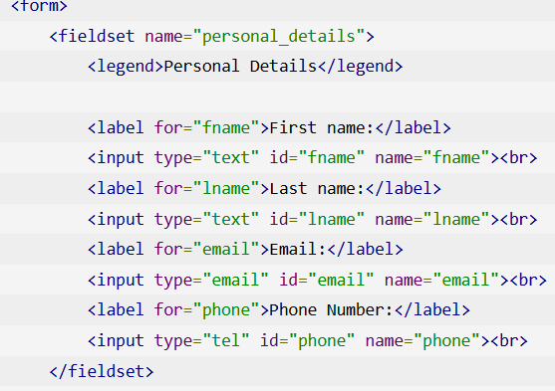

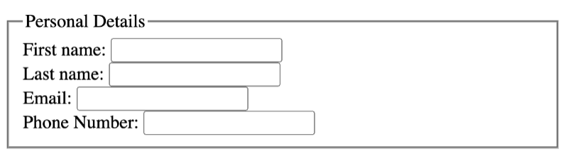

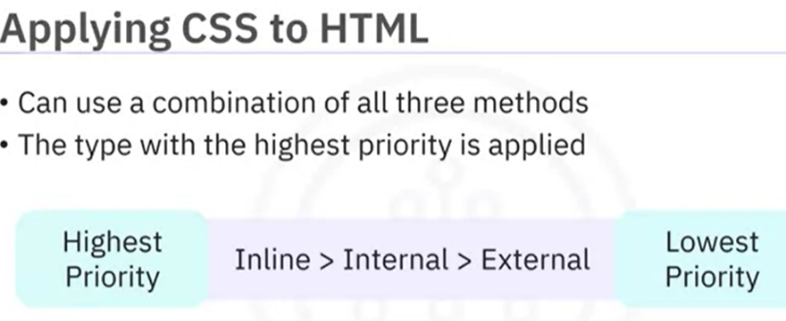

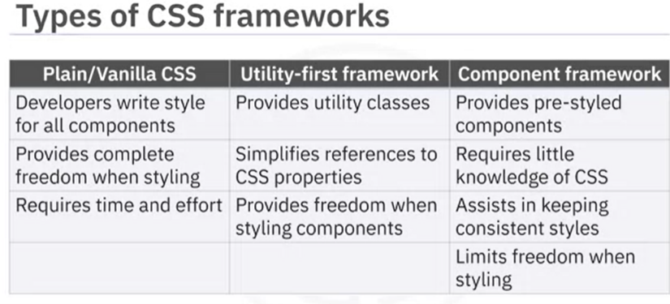

To change a link turn into red color while hovering on it

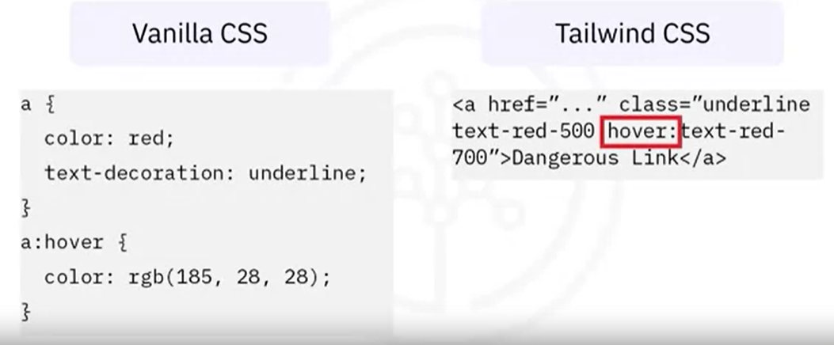

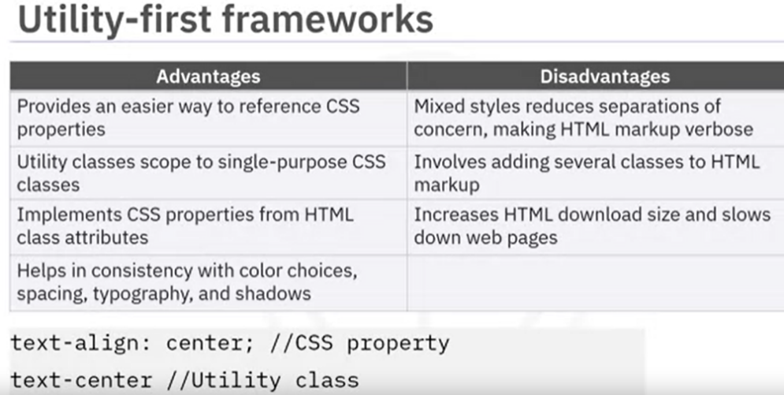

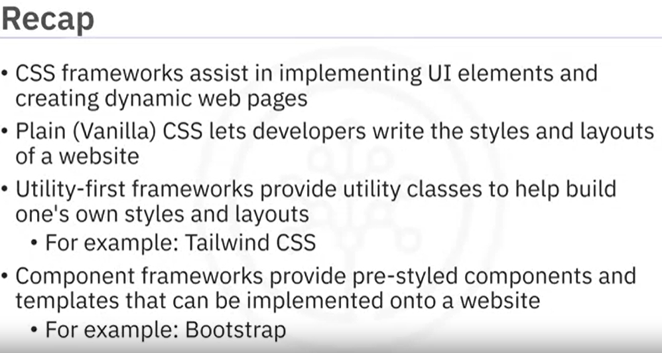

* + You specify a color for an element using a predefined color name, or by using RGB, HEX, HSL, RGBA, or HSLA values.

**Common attributes of the input tag:**

* + **Number:**

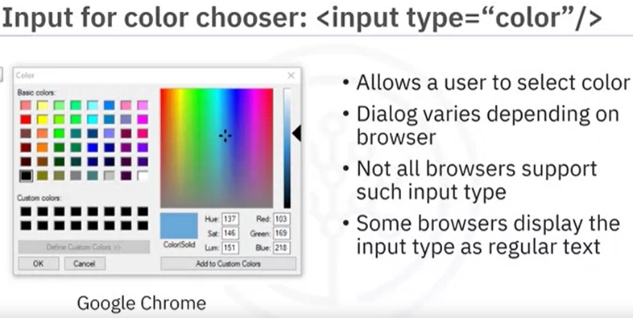

**Date:**

Ex: <input type:"date"/>

* + A date control without timezone

**Datetime :**

Ex: <input type:"datetime-local"/>

* + Provides for a date and time year,month,day,hour,minute, AM/PM without timezone.

**Email:**

Ex: <input type:"Email"/>

Accepts only valid email format

**Number:**

Ex: <input type:"number"/>

Takes numeric value as input

**Range:**

Ex: <input type:"range"/>

Takes a numeric range as input

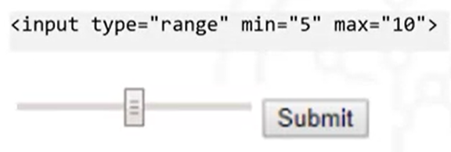

**Search:**

Similar to the text field, return a history of recently searched text strings.

**Telephone :**

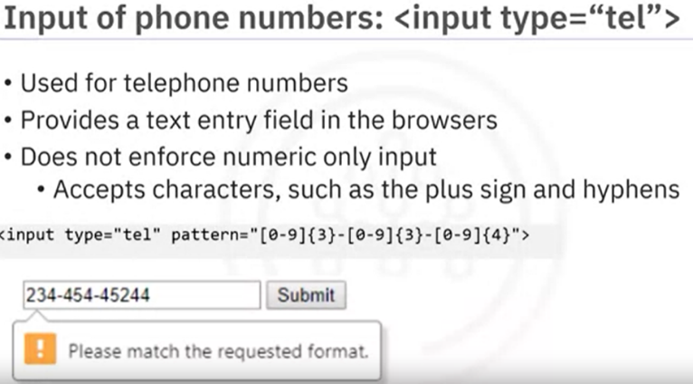

URL :

Validate and allows only properly formatted URL

Dataset:

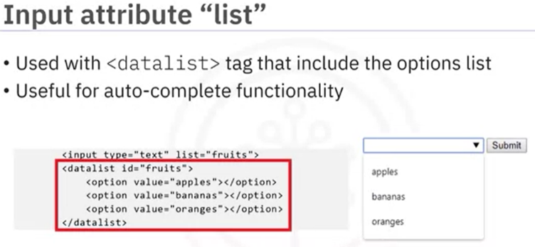

**Placeholder**:

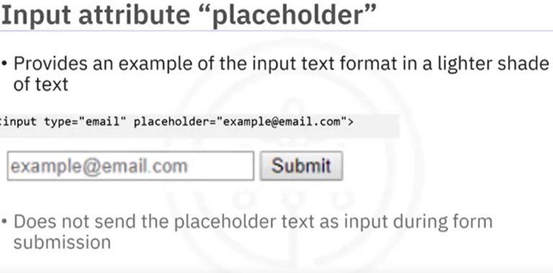

**Required**:

Indicates that the field is mandatory

Ex: <input type="email" required>

**CSS Styling:**

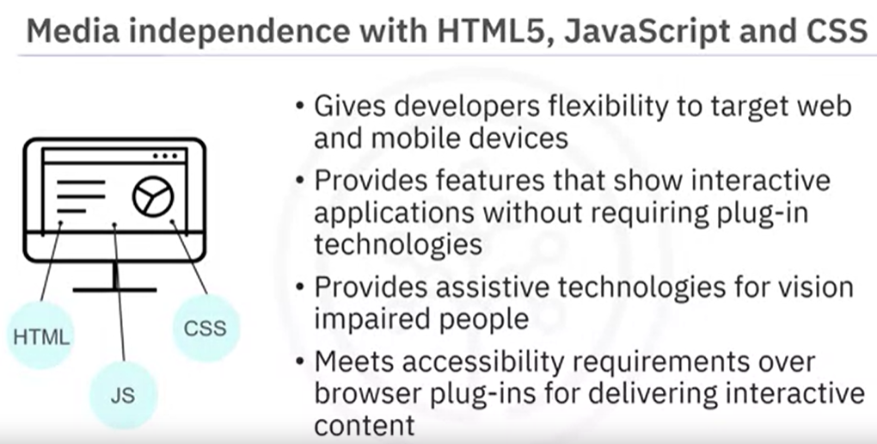

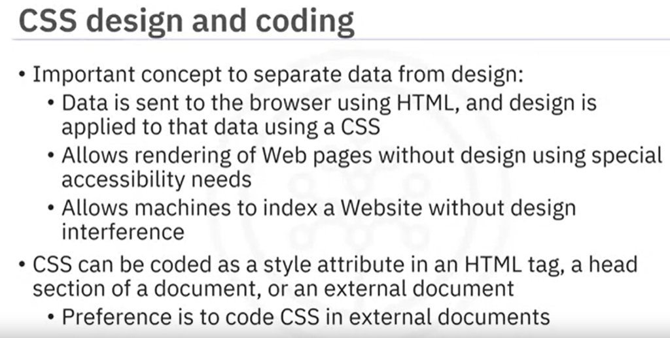

**Style rules for the following web page elements:**

* + Fonts
  + Text
  + Colors
  + Backgrounds
  + Sizes
  + Borders
  + Spacing
  + Positioning
  + Visual effects
  + Tables
  + Lists

**CSS Format:**

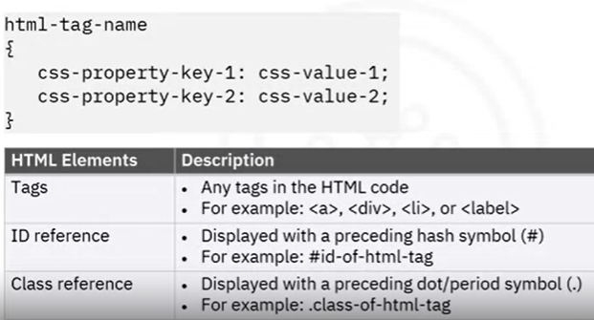

**Base style:**

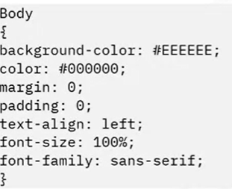

**Guidelines for base styles:**

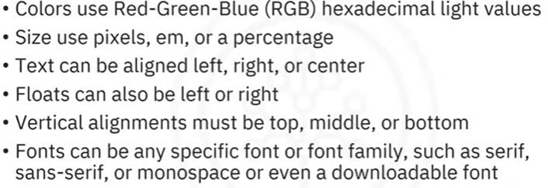

**Choosing Layout:**

**Fluid Layout:**

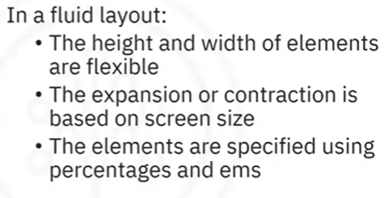

**Java script:**

* + Derived from the ECMA script standard
  + Designed to run on netscape navigator browser
  + Interpreted language
  + Adds dynamic web contents
  + **var** - **global scope** and **let** - **scope within the block** where it is created.

**Wrapper objects:**

**Variables and Control statements:**

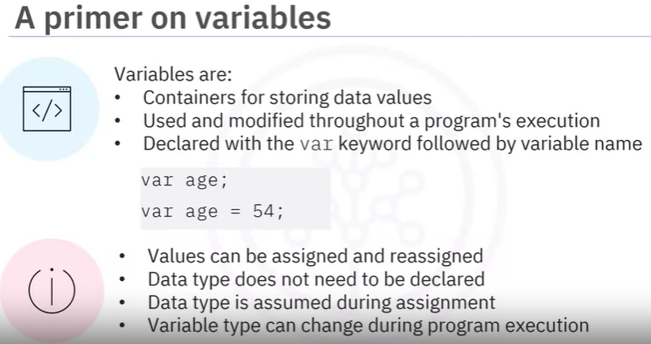

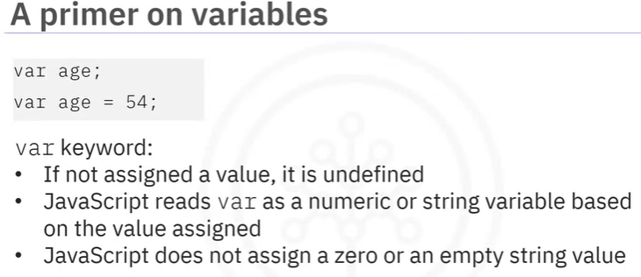

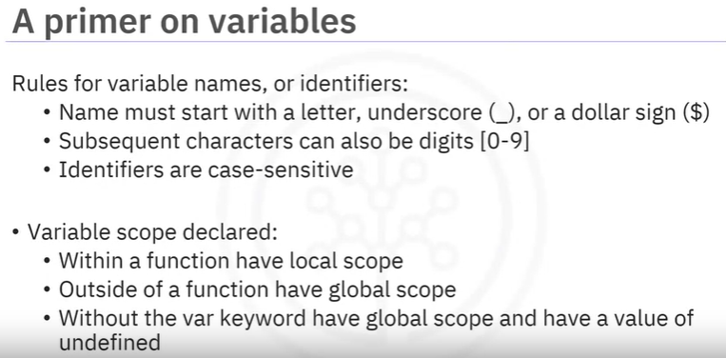

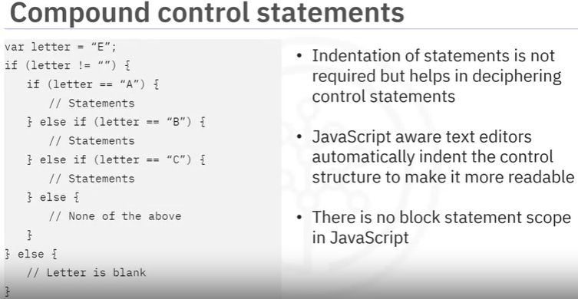

Block statement - if a variable is declared inside if block it can be used outside the block

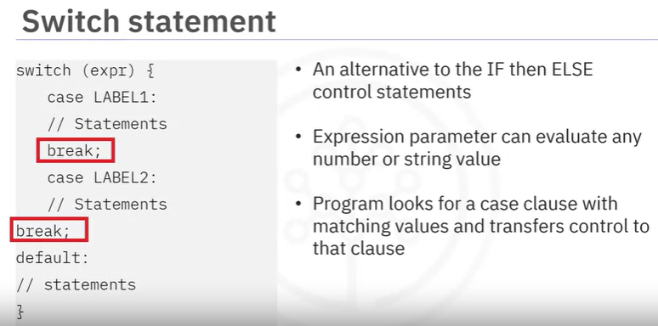



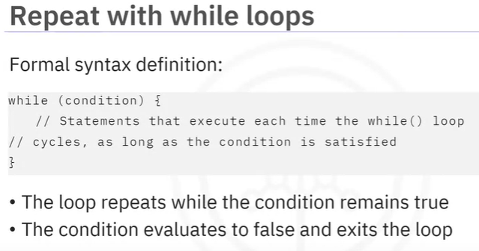

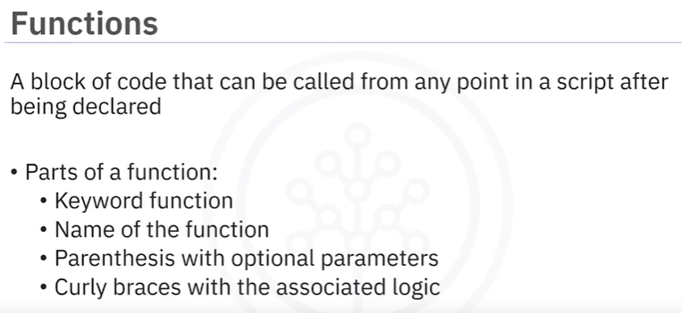

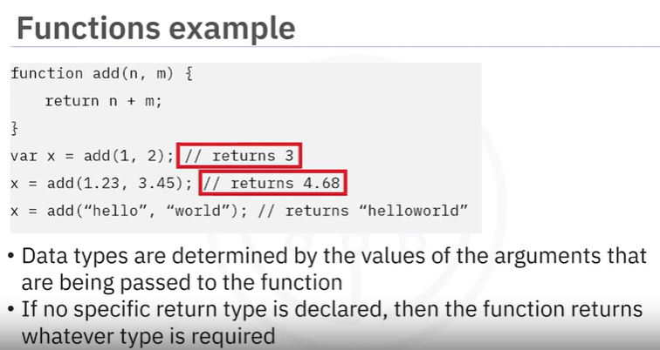

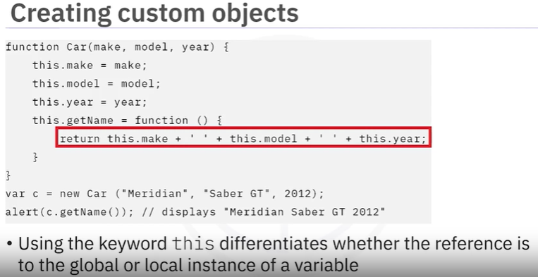

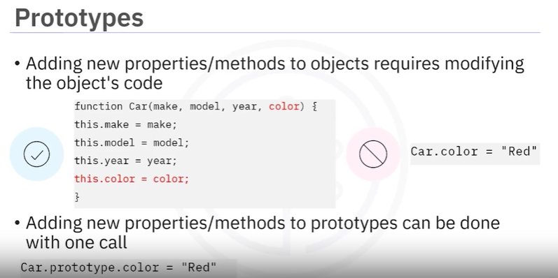

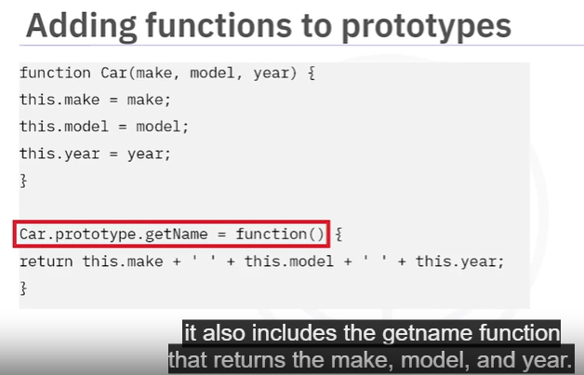

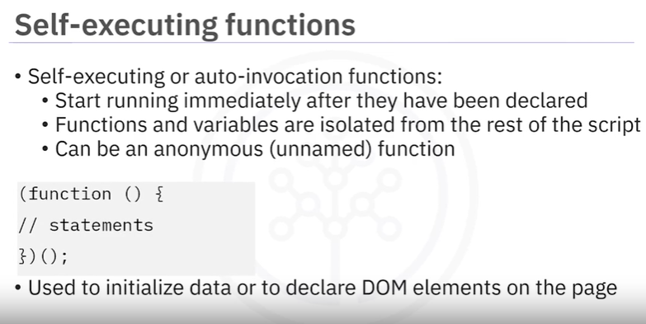

**JavaScript APIs:**

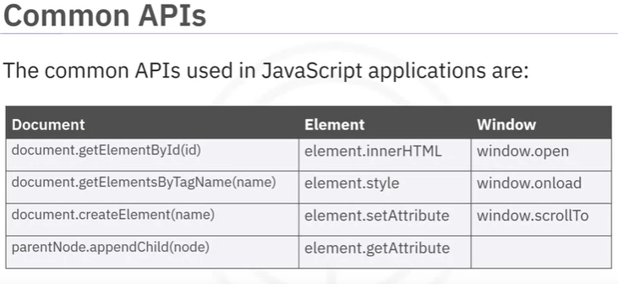

**Use document.getElementById to:**

* + Pass the id value as an argument
  + Return one specific HTML or XML element that is based on the id attribute in the node

**Use document.getElementByTagName to:**

* + Retrieves a nodeList of elements with a specified tag name
  + Nodelist contains an array of elements in the document

* + 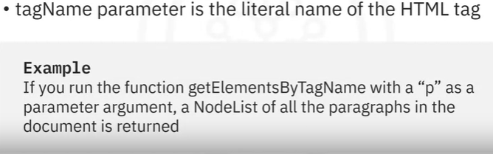

* + 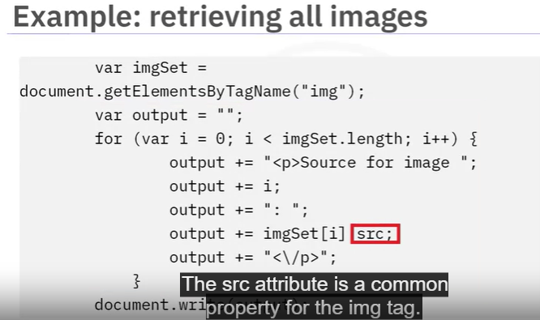
  + The last line is, document.write() function - adds the script-generated HTML to the document

**Use document.createElement(tagName) to:**

* + Create a new element with the namespace of the current document, after creation can use any number of functions to place the element in the appropriate location within the document

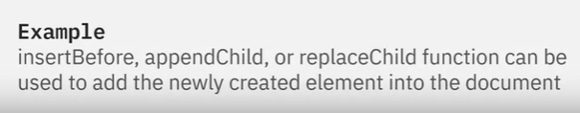

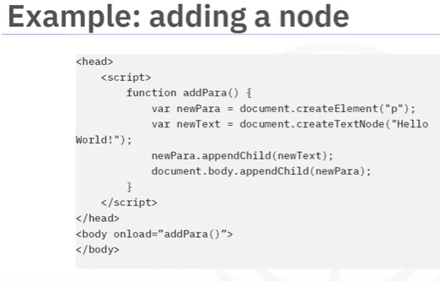

**Use element.innerHTML to,**

* + Retrieve / set the content within an HTML element
  + Returns all child elements as a text string
  + Allows content change of an HTML element
  + Removes all current child elements by setting value to string
  + Browser parses the string and sets the contents of the HTML element

**Use element.style**,

* + Retieves / sets the inline CSS style for a particular element
  + Overrides setting from a CSS style sheet with one specific style

* + 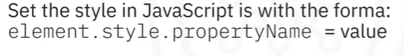

* + 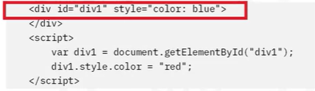

Here, the tag is used to group block elements to format them with a color style. It can be changed using the line number 5. Using the element.setAttribute('style',…) wipes out all previously set inline CSS styles.

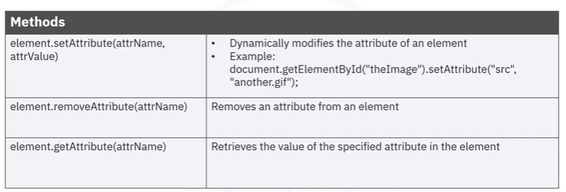

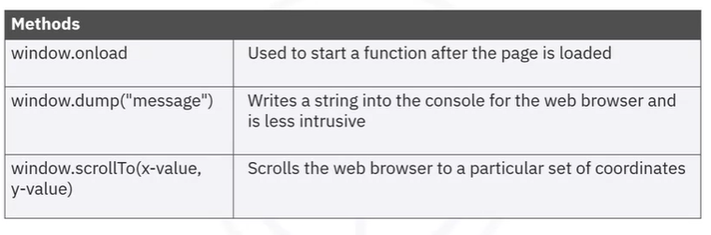

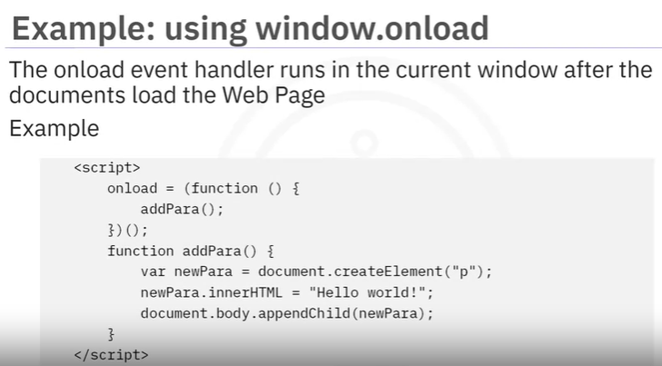

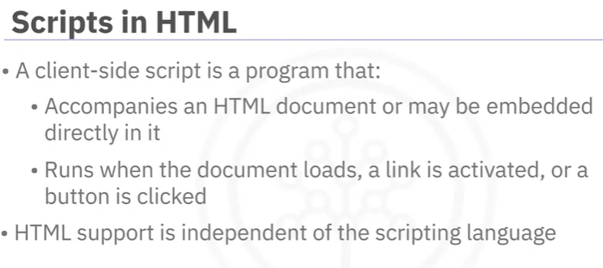

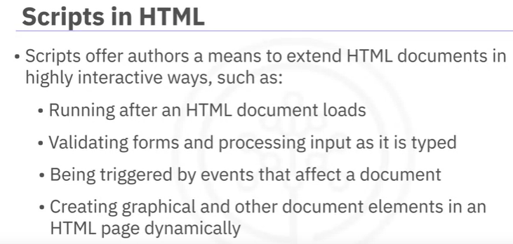

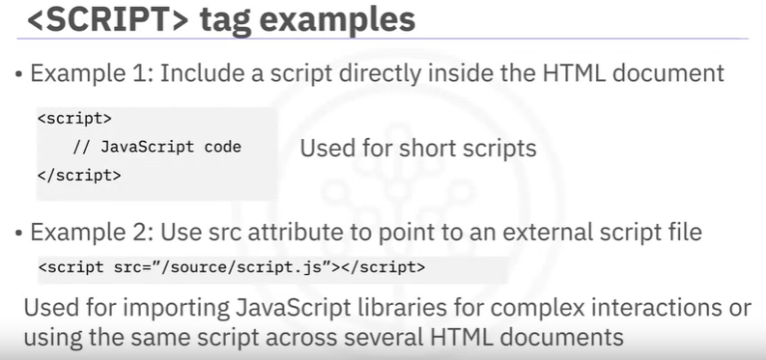

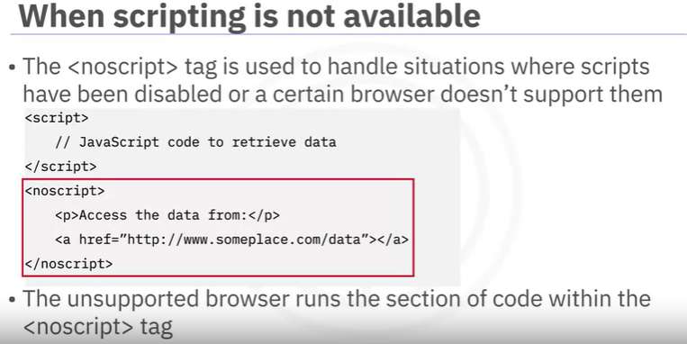

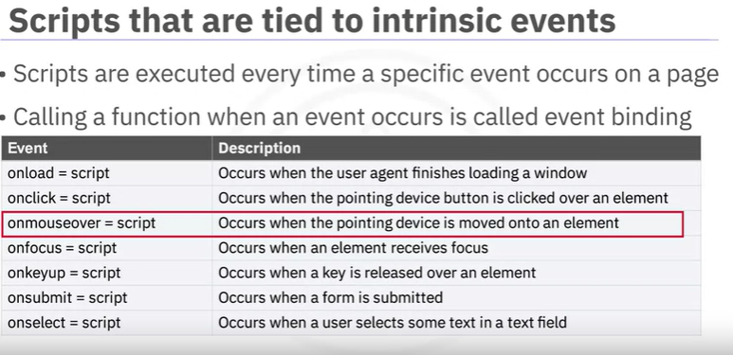

The username.focus() statement is used to bring the input focus back to the element where we found a problem, in this case, username.

**Note:** To set the value for a input field, document.getElementById('f').value = celci

DOM Document Object Model:

It is the programming interface between HTML and XHTML and JavaScript

Used to dynamically access and update the content, structure and style of documents

Also access and modify web page elements in the browser.

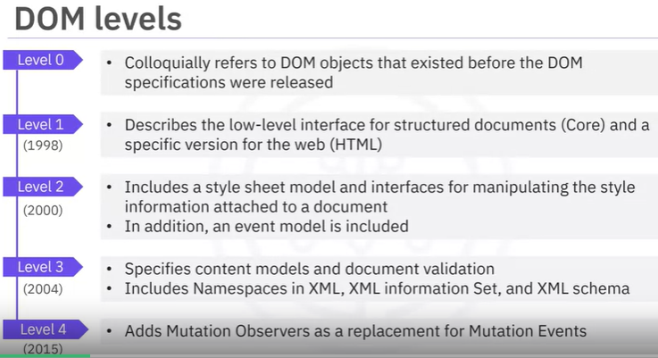

**DOM models for browser:**

**Window :** top of the DOM hierarchy. Controls environment that contains the document

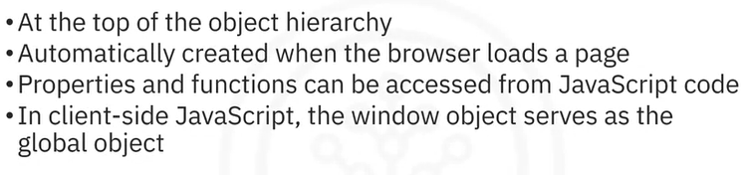

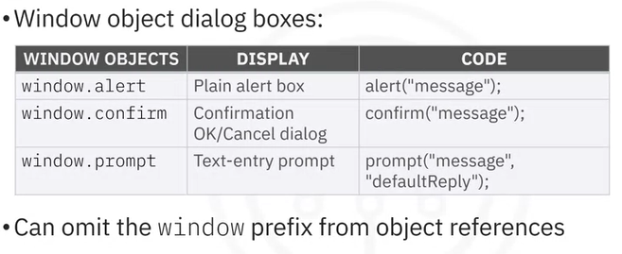

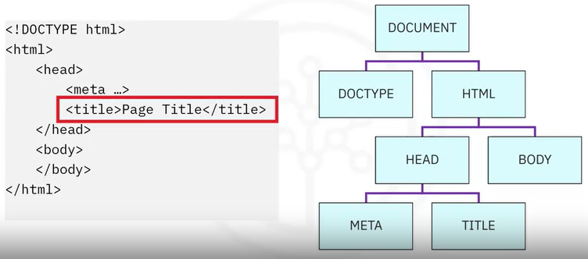

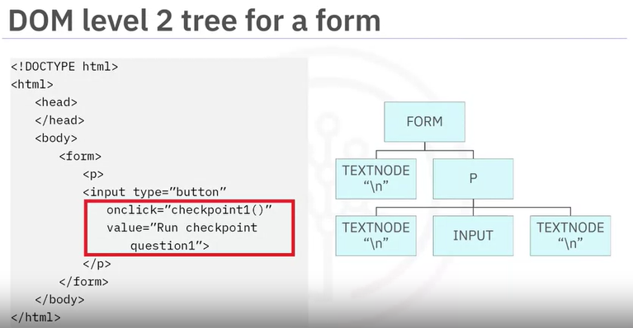

**History :** Keeps internal details about the recent history of pages in the browser. It has the methods to simulate clicking the back / forward

**Location :** info abouts the URL of a page

**Navigator** : object representation of the client internet/ user agent. As there is no standard applies to the navigator object, the property values returned when running queries on the navigator

**Screen :** determines the size of the screen

**Document**: This object provides access to all HTML elements within a page . Each HTML document that gets loaded into a window becomes a document object

